Diagram 1: Public Access and Customer Functions

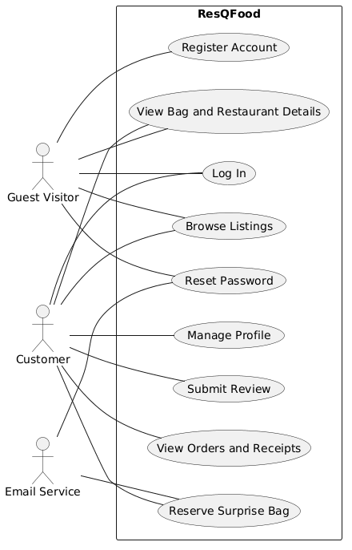

Diagram 2: Restaurant Owner and Worker Functions
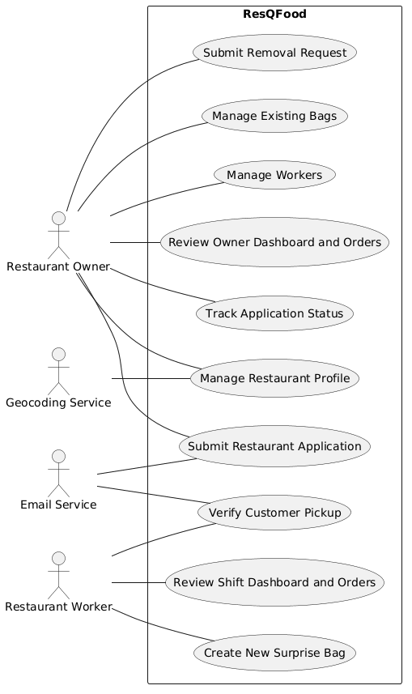
Diagram 3: Administrative Functions
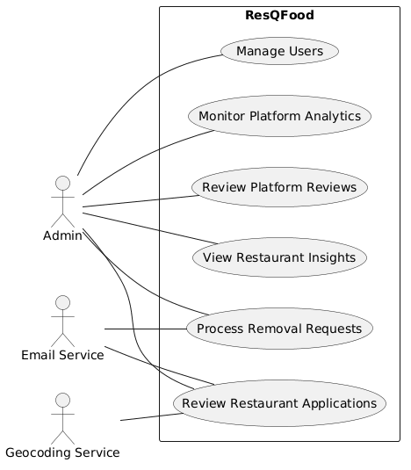

Diagram 4: Consolidated System Context Use Case Diagram
